**NVIDIA RTX 3050 INSTALLTION MANUAL**

This is a user manual created to help with the installation of NVIDIA RTX 3050 driver and getting the system ready for configuring Deep Learning Applications.

**Installing GeForce RTX 3050 NVIDIA Driver**

**Q. Steps to install the GeForce RTX 3050 NVIDIA driver on computer.**

Here are the steps to install the NVIDIA GeForce RTX 3050 graphics card driver on a computer:

1. Go to the NVIDIA website (www.nvidia.com) and click on the "Drivers" section.
2. Select "GeForce" from the product type drop-down menu and "GeForce RTX 3050" from the product series drop-down menu.
3. Choose your operating system (e.g. Windows 10) and click "Search."
4. Download the latest available driver for the GeForce RTX 3050 by clicking the "Download" button.
5. Save the driver file to your computer and double-click the file to start the installation process.
6. Follow the on-screen instructions to install the driver.
7. Once the installation is complete, restart your computer.
8. Verify that the NVIDIA GeForce RTX 3050 is functioning properly by checking the Device Manager or running benchmarks.

Note: If you already have an older version of the NVIDIA driver installed, you may need to uninstall it first before installing the new driver. You can do this using the "Programs and Features" or "Apps & Features" control panel in Windows.

**Q. How to check the driver version of NVIDIA Graphic card**

Here are the steps to check the version of the NVIDIA graphics card driver on a Windows computer:

1. Right-click the Windows Start button and select "Device Manager."
2. Expand the "Display adapters" section.
3. Right-click on your NVIDIA graphics card and select "Properties."
4. Go to the "Driver" tab.
5. The version of the driver is listed under "Driver version."

Alternatively, you can also check the version of the NVIDIA graphics card driver by using the NVIDIA Control Panel:

1. Right-click the Windows desktop and select "NVIDIA Control Panel."
2. Go to the "System Information" section.
3. The version of the NVIDIA graphics card driver is listed under "Driver Version."

Note: The specific steps to check the driver version may vary depending on the operating system and version you are using.

**Q. What download type to choose in NVIDIA Driver downloads GRD or SD**

In NVIDIA driver downloads, you have the option to choose between "GRD (Graphics Driver)" and "SD (System Driver)".

1. GRD (Graphics Driver): This type of driver is specifically designed to enhance the performance and functionality of your NVIDIA graphics card. It includes support for all the latest features and optimizations to ensure the best performance for your graphics card.
2. SD (System Driver): This type of driver is designed to enhance the performance and stability of your entire system, including your NVIDIA graphics card. It includes support for features like NVIDIA GeForce Experience and other system-level optimizations.

Typically, the GRD (Graphics Driver) is recommended for most users as it provides the best performance and support for your NVIDIA graphics card. However, the SD (System Driver) is also a good option if you require enhanced system-level performance and stability. The choice between the two will depend on your specific needs and requirements.

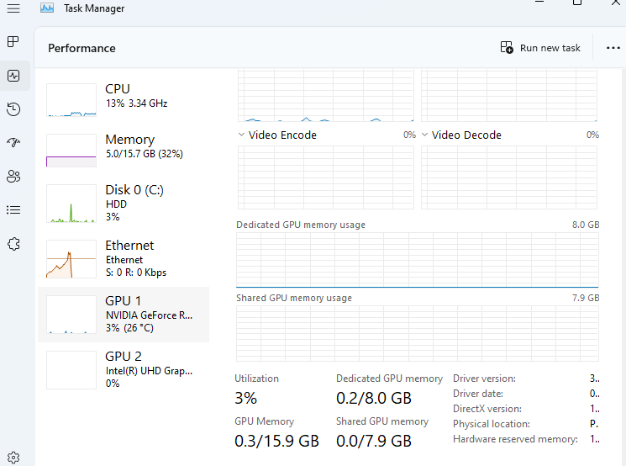

Once the installation of the driver has been completed, on opening the Task Manager you can check another GPU has been added named as NVIDIA GeForce RTX 3050.

**Q. Which installation option to choose in the NVIDIA installer?**

When installing NVIDIA graphics card drivers using the NVIDIA installer, you will typically have two options to choose from: "Custom" and "Express".

1. Custom: This option allows you to customize the installation process and select the specific components you want to install. You can choose to install only the graphics driver, only the NVIDIA Control Panel, or both. This option is recommended for advanced users who want to control the installation process and have specific requirements.
2. Express: This option is the recommended option for most users. It installs the graphics driver and the NVIDIA Control Panel, along with any necessary system components. This option is quick, easy, and provides the best overall experience for most users.

If you are unsure which option to choose, it is recommended to choose the Express option as it provides a comprehensive installation and the best overall experience for most users.

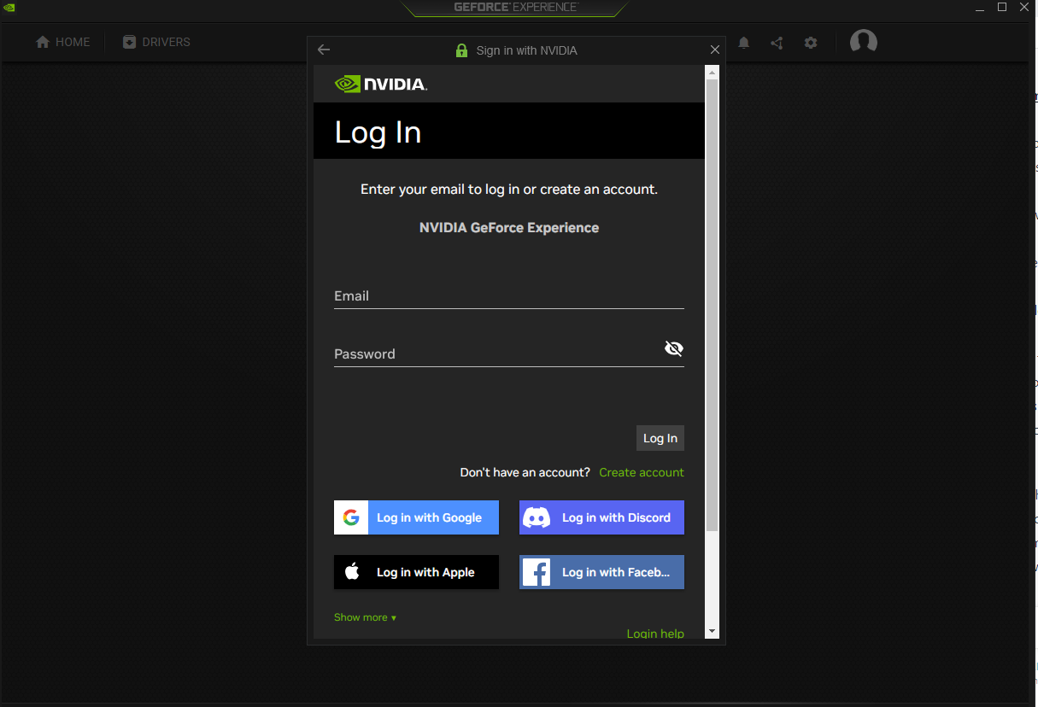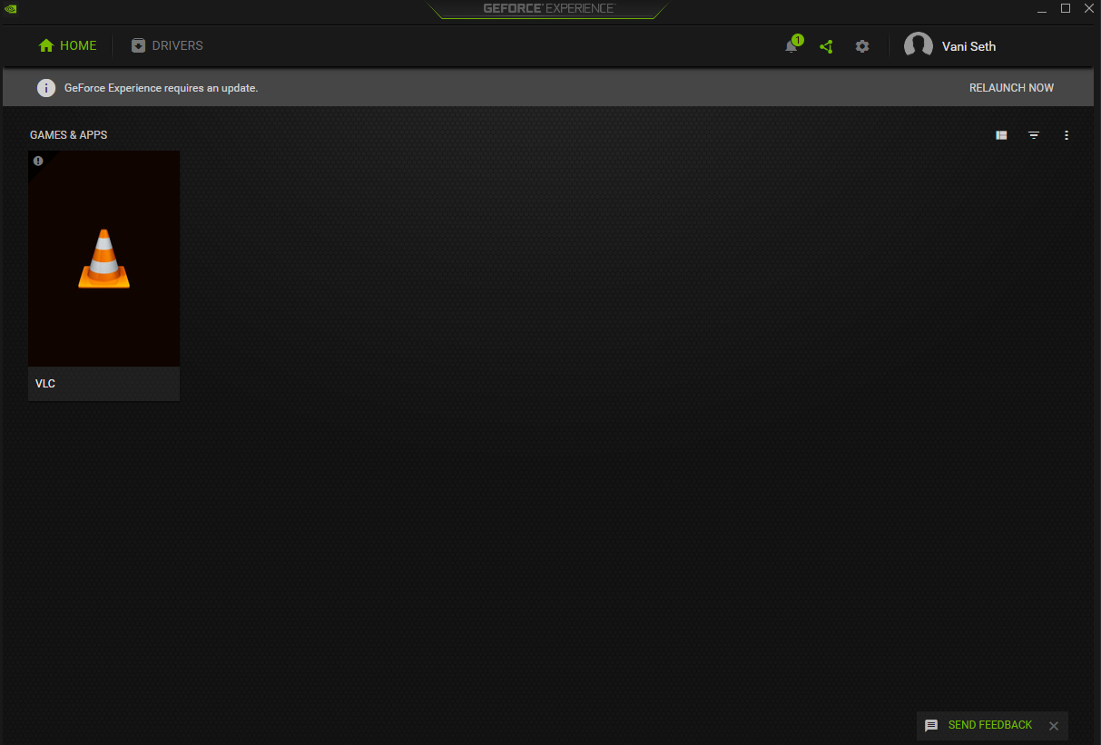

Make an account if you do not already have or login with Google. Once you are logged in, your dashboard will open.

Once the dashboard opens, you have successfully installed NVIDIA Driver in your system.

Now we need to make our system capable of running and configuring deep learning programs.

**Configuring Deep Learning Programs**

**Q. How to configure deep learning programs using GForce RTX 3050 NVIDIA Driver**

The configuration process for deep learning programs using the NVIDIA GeForce RTX 3050 driver will depend on the specific deep learning software you are using. However, here are some general steps you can follow to configure deep learning programs:

1. Install the latest NVIDIA graphics card driver for your GeForce RTX 3050. You can download the driver from the NVIDIA website (www.nvidia.com) and follow the instructions provided in the installation wizard.
2. Install the deep learning software you want to use. This can be a deep learning framework such as TensorFlow, PyTorch, or Caffe, or a deep learning application such as NVIDIA DIGITS or CUDA-Z.
3. Verify that the deep learning software you installed is using the NVIDIA GPU. You can do this by checking the system requirements for the specific software or by using system monitoring tools like NVIDIA System Management Interface (nvidia-smi) or GPU-Z.
4. Configure the deep learning software for your specific use case. This may include setting the number of GPUs to use, specifying the GPU memory to allocate, and configuring other performance-related settings.
5. Start using the deep learning software to build and train your deep learning models.

Note: The exact steps for configuring deep learning programs may vary depending on the specific deep learning software you are using. Be sure to consult the documentation and support resources provided by the software vendor for more information.

**Q. How to install TensorFlow on GeForce Workspace**

To install TensorFlow on the GeForce Workspace, you need to follow these steps:

1. Install the latest version of Python. TensorFlow supports Python 3.5 or higher. You can download the latest version of Python from the official Python website (python.org) and follow the installation instructions.
2. Install the NVIDIA GPU drivers for your GeForce RTX 3050 graphics card. You can download the latest drivers from the NVIDIA website (www.nvidia.com) and follow the instructions provided in the installation wizard.
3. Install the NVIDIA CUDA Toolkit. TensorFlow requires the NVIDIA CUDA Toolkit to use your GPU. You can download the latest version of the CUDA Toolkit from the NVIDIA website (developer.nvidia.com/cuda-downloads) and follow the installation instructions.
4. Install the NVIDIA cuDNN library. TensorFlow also requires the NVIDIA cuDNN library for GPU acceleration. You can download the latest version of cuDNN from the NVIDIA website (developer.nvidia.com/cudnn) and follow the installation instructions.
5. Install TensorFlow. You can install TensorFlow using the pip package manager by running the following command in your terminal or command prompt: "pip install tensorflow-gpu"
6. Verify the installation. To verify the installation, you can start a Python session and run the following command: "import tensorflow as tf; print(tf.reduce_sum(tf.random.normal([1000, 1000])))". This will perform a simple computation using TensorFlow and verify that it is working correctly.

These are the basic steps to install TensorFlow on the GeForce Workspace. For more information on TensorFlow, including system requirements and usage instructions, refer to the TensorFlow website (tensorflow.org).

**Q. How to install CUDA toolkit**

To install the NVIDIA CUDA Toolkit on your computer, you need to follow these steps:

1. Download the CUDA Toolkit installer. You can download the latest version of the CUDA Toolkit from the NVIDIA website (developer.nvidia.com/cuda-downloads).
2. Run the CUDA Toolkit installer. Double-click the downloaded installer file and follow the on-screen instructions to start the installation process.
3. Accept the license agreement. Read the license agreement and accept it to continue with the installation.
4. Choose the installation type. Select "Custom (Advanced)" installation type to choose which components of the CUDA Toolkit to install. You can choose to install only the necessary components or install all components, depending on your needs.
5. Choose the installation location. Specify the location where you want to install the CUDA Toolkit. The default location is usually fine.
6. Install the CUDA Toolkit. Click the "Install" button to start the installation process. Wait for the installation to complete.
7. Update your PATH environment variable. Add the CUDA Toolkit bin directory to your PATH environment variable. You can do this by adding the following line to your shell startup script (e.g., .bashrc or .bash_profile):